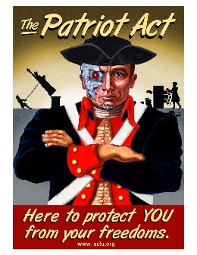
Individual and Society
Persuasive Letter Rubric
Name: _______________________ TOTAL: __________/100 Summative
Element | 1 Inadequate | 2 Adequate | 3 Effective | 4 Superior
Argumentation | Inadequately incorporates appropriate and cogent arguments from media, reading, and experience blending at least two different types of appeals into a sophisticated argument | Adequately incorporates appropriate and cogent arguments from media, reading, and experience blending at least two different types of appeals into a sophisticated argument | Effectively incorporates appropriate and cogent arguments from media, reading, and experience blending at least two different types of appeals into a sophisticated argument | Skillfully incorporates cogent arguments from media, reading, and experience blending at least two different types of appeals into a sophisticated argument
Synthesis | Draws inaccurate or highly debatable information from one or more sources; thesis is unclear, support is limited | Draws debatable information from one or more sources including Crucible; the thesis and position on individual and society are clear but support is uneven or limited | Synthesizes accurate and apt information from one or more sources including The Crucible; clear thesis on individual and society with effective support | Expertly synthesizes convincing information from multiple sources including the Crucible; strong thesis and persuasive support on individual and society
Organization and focus | Inadequate organization; may lack clear development, focus, or connection between ideas | Paragraphs and sentences flow in an adequate fashion; may be some rambling or lack of clear pattern | Paragraphs and sentences flow in an effective fashion; logical organization of paragraphs | Paragraphs and sentences flow in a sophisticated fashion; logical organization of paragraphs
Voice | The text does not incorporate the individual voice; writing is generic. | Portions of the text incorporate the individual voice. | Text incorporates the individual voice in sentence variety and style. | Text highlights the individual voice in sentence variety and style.
Grammar, Mechanics, and Formatting | Major flaws in the category of proper English usage and control of grammar, sentence and paragraph structure, diction, and syntax.  Format is incorrect or missing major elements. | Several minor flaws in the category of proper English usage and control of grammar, sentence and paragraph structure, diction, and syntax.  Minor flaws in paper format. | Demonstrates an understanding of proper English usage and control of grammar, sentence and paragraph structure, diction, and syntax.  Basic formatting (double space, MLA Header, etc.) | Demonstrates a sophisticated command of usage and control of grammar of grammar, sentence and paragraph structure, diction, and syntax.  Appropriate formatting (double space)

