AP Argumentative Essay on The Crucible and Summer Reading
2009 AP® ENGLISH LANGUAGE AND COMPOSITION FREE-RESPONSE QUESTIONS (Modified for Summer Reading)
Wren, Morris, and Gingrich AP Lang Fall 2018

Adversity has the effect of eliciting talents which in prosperous circumstances would have lain dormant.
—Horace
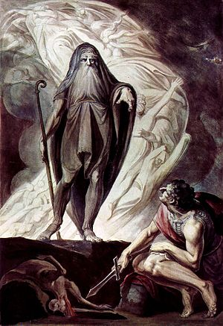
Consider this quotation about adversity from the Roman poet Horace. Then write an essay that defends, challenges or qualifies Horace’s assertion about the role that adversity (financial or political hardship, danger, misfortune, etc.) plays in developing a person’s character. Support your argument with appropriate evidence from your reading, observation, or experience. You must make two direct references to The Crucible by Arthur Miller and two direct references to your summer reading. Include a bibliography of your summer reading book at the end of the paper.

- This is open book, you must make at least two references to your summer reading-direct quotes
- Other references may come from your
Readings (books inside and outside of school)
Observations including media and “real” world observations
Personal experiences

Use of Appeals
- Use at least two logical appeals: cause and effect, syllogism, definition, and analogy
- You may use additional logical appeals or emotional appeals (emotion, value) or appeals to ethos (validity or authority of the speaker)

You will have one period to refer to your books, write a draft and turn the rough draft into turnitin.com.
You will have one period to look over your draft revise and turn in your final copy to turnitin.com.

Rough Draft is due end of period September 10th
2nd Draft is due end of period September 18th

