Grammar Lesson 3: Sentence Patterns
Four Types of Sentences:
Simple: One independent clause (noun and verb)

Complex: One independent clause and one or more dependent clause

Compound: Two or more independent clauses

Compound-complex: Two independent and one or more independent clauses

There are ten sentence patterns which can be found at :
http://www.towson.edu/ows/sentpatt.htm

Sentence patterns
Just about all sentences in the English language fall into ten patterns determined by the presence and functions of nouns, verbs, adjectives, and adverbs.
The patterns are most easily classified according to the type of verb used:
Verb of being patterns (1, 2, 3) use a form of the verb to be as the main verb in the sentence.
is are was were has been have been had been
Linking verb patterns (4, 5) use one of the linking verbs as the main verb in the sentence. The linking verb is followed by a noun or adjective functioning as a subjective complement.
smell taste look feel seem become appear grow
Action verb patterns (6, 7, 8, 9, 10) use one of the many action verbs as the main verb in the sentence. The action verb may be either transitive (take a direct object) or intransitive (not take a direct object).
see jump embrace write imagine buy plummet think etc.

Terms used to identify various parts of each sentence pattern include the following:
- NP = noun phrase
This abbreviation refers to a headword noun and its modifiers ("noun phrase") functioning as a subject, direct object, indirect object, subjective complement, or objective complement.
- NP1, NP2, NP3, etc. = designations for different noun phrase functions
Numbers in sequential order are used with each NP to designate its difference from or similarity to other NPs before and after it.
- V-be = verb of being
- LV = linking verb
- V-int = intransitive verb
- V-tr = transitive verb
- ADV/TP = adverbial of time or place
- ADJ = adjective

THE TEN SENTENCE PATTERNS
1. NP1 + V-be + ADV/TP
The verb of being is followed by an adverb indicating where or when.
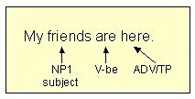 More information on subjects
The adverbial indicating where or when may be a prepositional phrase.
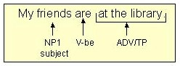
2. NP1 + V-be + ADJ
The verb of being is followed by an adjective that functions as the subjective complement.
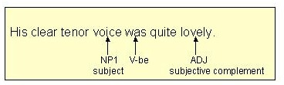 More information on subjective complements
The adjectival functioning as the subjective complement may be a prepositional phrase.
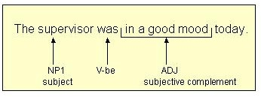

3. NP1 + V-be + NP1
The verb of being is followed by a noun that functions as the subjective complement.
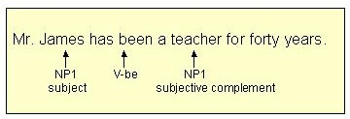
Note: The second NP receives the same numerical designation as the first NP because the second NP, the subjective complement, is the same as the subject (Mr. James = teacher).
4. NP1 + LV + ADJ
The linking verb is followed by an adjective functioning as a subjective complement.
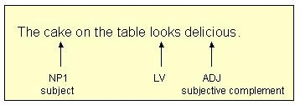
The adjectival functioning as the subjective complement may be a prepositional phrase.
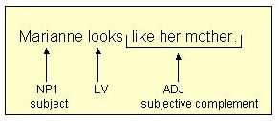
5. NP1 + LV + NP1
The linking verb is followed by a noun functioning as a subjective complement.
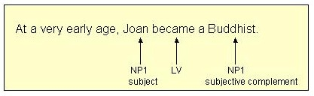
Note: The second NP receives the same numerical designation as the first NP because the second NP, the subjective complement, is the same as the subject (Joan = Buddhist).
6. NP1 + V-int
The action verb takes no direct object.
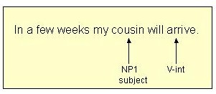
Even if the action verb is followed by a prepositional phrase, the verb is still intransitive as long as it does not take a direct object.
7. NP1 + V-tr + NP2
The action verb is followed by a direct object.
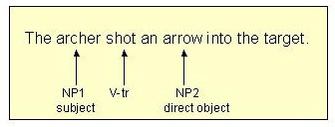 More information on direct objects
Note: The second NP, the direct object, receives a different numerical designation (NP2) because it is not the same as the subject (NP1).
8. NP1 + V-tr + NP2 + NP3
The action verb is followed by an indirect object and then a direct object.
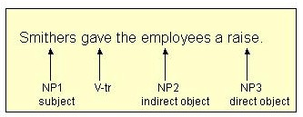 More information on indirect objects
Note: The indirect object and the direct object each receive a new numerical designation because each is different from the other and both are different from the subject.
9. NP1 + V-tr + NP2 + ADJ
The action verb is followed by a direct object. The direct object is followed by an adjective functioning as an objective complement.
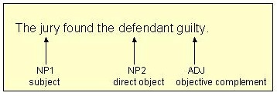 More information on objective complements
Note: The second NP, the direct object, receives a different numerical designation (NP2) because it is not the same as the subject (NP1).
10. NP1 + V-tr + NP2 + NP2
The action verb is followed by a direct object. The direct object is followed by a noun functioning as an objective complement.
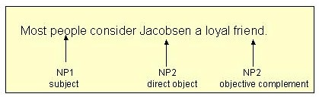
Note: The second NP, the direct object, receives a different numerical designation (NP2) because it is not the same as the subject (NP1). The third NP, the objective complement, receives the same numerical designation as the direct object (NP2) because it is the same as the direct object (Jacobsen = friend).

Put it together assignment
A. The Following paragraph comes from Nathaniel Hawthorne’s “The Birthmark”
On the bottom of the page label each sentence by the type it is. How does Hathorne use syntax to create mood in this passage?
1.To explain this conversation it must be mentioned that in the centre of Georgiana's left cheek there was a singular mark, deeply interwoven, as it were, with the texture and substance of her face. 2. In the usual state of her complexion--a healthy though delicate bloom--the mark wore a tint of deeper crimson, which imperfectly defined its shape amid the surrounding rosiness. 3. When she blushed it gradually became more indistinct, and finally vanished amid the triumphant rush of blood that bathed the whole cheek with its brilliant glow. 4. But if any shifting motion caused her to turn pale there was the mark again, a crimson stain upon the snow, in what Aylmer sometimes deemed an almost fearful distinctness. 5. Its shape bore not a little similarity to the human hand, though of the smallest pygmy size. 6. Georgiana's lovers were wont to say that some fairy at her birth hour had laid her tiny hand upon the infant's cheek, and left this impress there in token of the magic endowments that were to give her such sway over all hearts. 7. Many a desperate swain would have risked life for the privilege of pressing his lips to the mysterious hand. 8. It must not be concealed, however, that the impression wrought by this fairy sign manual varied exceedingly, according to the difference of temperament in the beholders. 9. Some fastidious persons--but they were exclusively of her own sex--affirmed that the bloody hand, as they chose to call it, quite destroyed the effect of Georgiana's beauty, and rendered her countenance even hideous. 10. But it would be as reasonable to say that one of those small blue stains which sometimes occur in the purest statuary marble would convert the Eve of Powers to a monster. 11. Masculine observers, if the birthmark did not heighten their admiration, contented themselves with wishing it away, that the world might possess one living specimen of ideal loveliness without the semblance of a flaw. 12. After his marriage,--for he thought little or nothing of the matter before,--Aylmer discovered that this was the case with himself
1.
2.
3.
4.
5.
6.
7.
8.
9.
10.
11.
12.
B. Describe a small boy making a mess in a restaurant. Begin with a simple sentence, followed by a complex sentence, followed by a compound sentence, followed by compound-complex sentence.

